Nepal College of Information Technology
Assessment
Spring 2011
Program : BE Time : 3 hrs
Semester : Spring (VIII) FM : 70
Subject : IP Switching and Routing PM : 35

- Candidates are requested to give their answer as far as practicable in their own words.
- The figure in the margin indicates the full marks
- Attempt ALL question

1. Consider the given topology shown below in figure 1. Provide the implementation of EIGRP routing with the following parameters. IP Addressing in all interfaces are required. [15]
EIGRP AS = 101
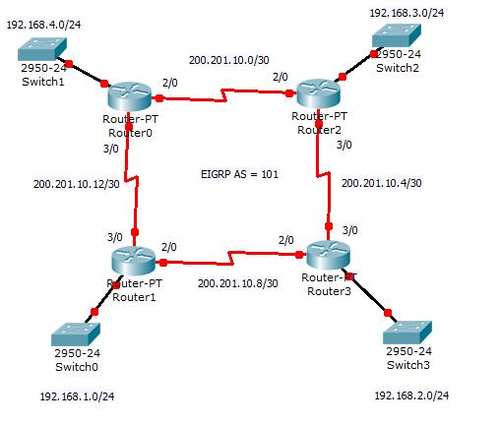
Figure 1: Network Topology

2. From the above Figure 1, Provide the Solution to enable Site to Site IPSec VPN across Router1 and Router3. You should use ISAKMP to define the Policy of VPN. [10]

3. From the figure 1, enable Secured Remote Access (SSH) to all the routers with username ADMIN and password CISCO. The Password to Enable Priviledge Mode should be Stored in MD5 hash [10]
4. Discuss the role of VLAN in Network design. Consider your own network topology and implement 4 different VLANs that support Inter VLAN routing.
Note #: Network should be three tired [Core, Distribution and Access] [10]
5. How PPP CHAP Authentication can be applied ? Provide the solution to enable PPP CHAP Authentication between two Routers connected with a Serial Cable. Provide your design and IP Addressing Plan. [10]
6. A Popular Commercial bank of Nepal consisting of 248 branch office is planning to implement Core Banking System (Finnacle). Provide the best network design of Data Center (DC) and Data Recovery Center (DRC) that enables 24/7 banking service to end customers. Your network design should include topology selection, routing protocol and IP addressing. [15]

